Vibe System Designing
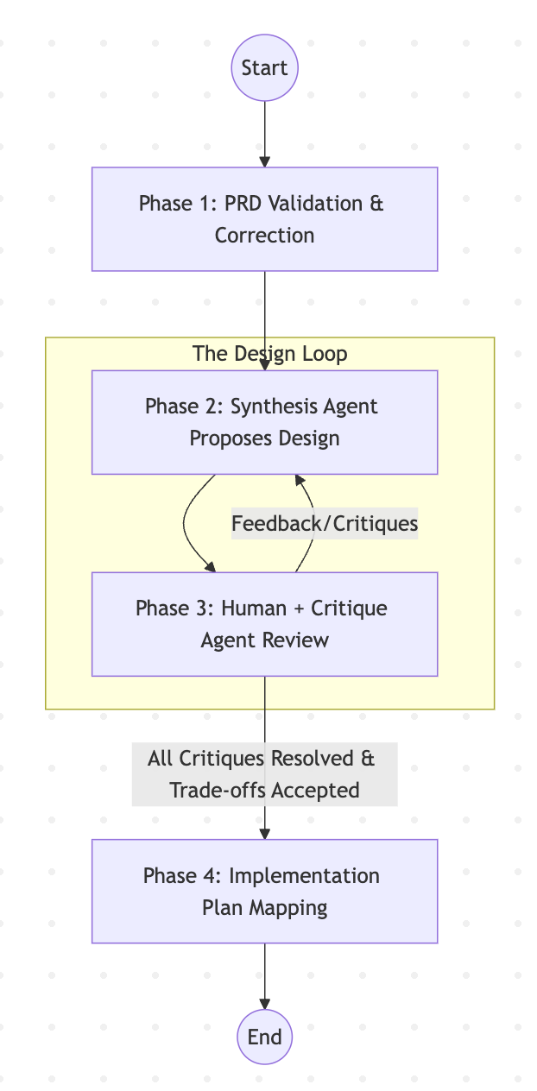

Phase 1: PRD Validation & Correction

Goal: Refine the initial requirements in prd.md to eliminate ambiguities and technical gaps.

- Agent Skills: Utilize validation skills found in .agent/skills/architecture-gatekeeper.

- Prompt: "@.agent/skills/architecture-gatekeeper Review the existing @prd.md. Identify any technical inconsistencies or missing requirements. Propose specific corrections to ensure the PRD is ready for architectural synthesis."

Output: The audited & refined PRD.md

Phase 2: Synthesis (Proposal) - Use a separated synthesis model

Goal: Generate the technical architecture based on the validated PRD.

- Agent Skills: Utilize synthesis and architectural design skills from .agent/skills/architecture-synthesis.

- Prompt (1st iteration): "@.agent/skills/architecture-synthesis Using the validated prd.md, propose a system design. Update current_state.md and create new documents in docs/adr (Architecture Decision Records) and visual diagrams that define the proposed solution."

- Prompt (for resolving criques): "@.agent/skills/architecture-synthesis “New criques came at @docs/hardening/00x_crique.md, check if they are reasonable, give your solutions, update your system design & current state"

- Note on reaction to critiques: The proposal agent should evaluate the critiques first: FIRST reason about validity. Do not blindly adjust. Defend the current design unless the critique proves a fatal flaw. (emphasize this in the skill file)

Outputs:
- Updated current state
- Architecture decision records with C4 diagrams

Phase 3: Critique (Feedback) - Use a separated critique model
Goal: Evaluate the proposed design for trade-offs, security, and scalability. This phase loops back to Phase 2 until all issues are resolved.

- Agent Skills: Use the critique agent logic defined in AGENTS.md and evaluation skills in .agent/skills.
- Prompt: "Act as a senior system architect. Analyze the latest design in docs/ and current_state.md. Identify potential bottlenecks, security risks, and technical trade-offs. Provide actionable feedback for the Synthesis Agent to address. Write them down to docs/hardening/00x_criques.md"

Phase 4: Implementation Plan Mapping
Goal: Transition the finalized, agreed-upon architecture into a concrete engineering roadmap.
- Agent Skills: Refer to the task-mapping and planning skills in .agent/skills/architecture-to-implementation-mapping.
- Prompt: "The architecture in current_state.md is now approved. Map this design to a detailed implementation plan. Breakdown the work into specific tasks, service boundaries, and data schemas for the engineering team to follow."

Artifacts
- prd.md: Audited prd with all requirements clarified for agents
- current_state.md: The latest state of the vibe system design process, how the system changed after each hardening round
- docs/adr/: append-only logs of architecture decisions
- docs/diagrams/: details of the latest design at c4 level (cover contexts -> containers -> components)
- docs/implementation-plan/: details of the implementation plan generated from the architecture design

Context loading

Goal: You open the project in a new session or use with a different ai coding assistant, you want to make the new AI easily understand & load the current project design with no hallucination

• Agent Skills: Refer to the architecture context loader skill at .agent/skills/architecture-context-loader.

• Prompt: "@.agent/skills/architecture-context-loader understand & load into your context the product requirements, latest system design & architecture decisions"

Phase 5: Change the design to adapt to a new feature / change request

We put the new change request as a markdown into docs/change-requests just need to repeat from Phase 1 -> Phase 4, with references to the change request file

Hands-on Practices
Example repo with agent skills & artifacts at: https://github.com/AnyAxis-Labs/vibe-system-design

